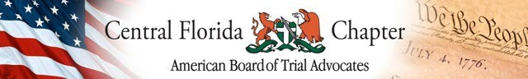

2023 NEW MEMBER NOMINATION FORM
To nominate a new chapter member, you must be a member of the ABOTA Central Florida Chapter. This form must be completed and sent to the Membership Committee Co-Chairs, Sam Cacciatore (Sam@Nancelaw.com), and Michele Morales (Michele.Morales@csklegal.com), and Executive Director, Kim Amos (execdir@cflabota.org) no later than August 15, 2023.

Chapter member making nomination:

Name and firm name of nominee:

How long have you known the nominee? Please give details (including specific example(s) of your interaction/relationship with the nominee.

Have you had any trials with the nominee? If so, how many?

What organizations have you participated in with the nominee?

Do you believe that the nominee will be an active member of ABOTA, and what kind of activities do you believe he/she would be most active?

To the best of your knowledge, is the nominee considered by the Bench and Bar to be of high personal character and honorable reputation?

List other ABOTA members you know who may or would support this nomination?

VERIFICATION: In nominating this individual for membership, I certify that I have a good faith belief that he/she has tried a minimum of ten civil jury trials to verdict as lead counsel. (Reminder: ABOTA defines Lead Counsel as one substantially responsible for the personal representation of the client during the trial. “Substantially responsible” means, at minimum, that the attorney has selected a jury, or given opening or closing, and has presented live witnesses through direct or cross examination).

Signature of member making nomination Date

Printed name of member making nomination

Submit the completed form no later than August 15, 2023 to:
Sam Cacciatore (Sam@Nancelaw.com)
Michele Morales (Michele.Morales@csklegal.com), and
Kim Amos (execdir@cflabota.org)

